DBMS – LAB -03

**NAME** : RAHUL VARMA

**ROLL NO**: S20200010212

**SECTION**: C

**TASK:** (LAB EXERCISES)

SQL COMMANDS

1. PRIMARY KEYS

2. FOREIGN KEYS

CREATING TABLE CUSTOMER:

create table customers(

CustomerID Int,

Dateofbirth date,

Gender varchar(5),

CustomerName varchar(30),

City varchar(20),

country varchar(10)

);

CREATING TABLE PRODUCTS:

create table products(

CustomerID Int,

ProductID int,

ProductName varchar(20),

Availability varchar(20),

Price int);

AND INSERTED THE VALUES GIVEN IN ASSIGNMENT AND ADDED SOME ROWS FOR THE REQUIREMENTS OF THE QUESTION.

1. Alter table and set CustomerID in Customers table as primary key

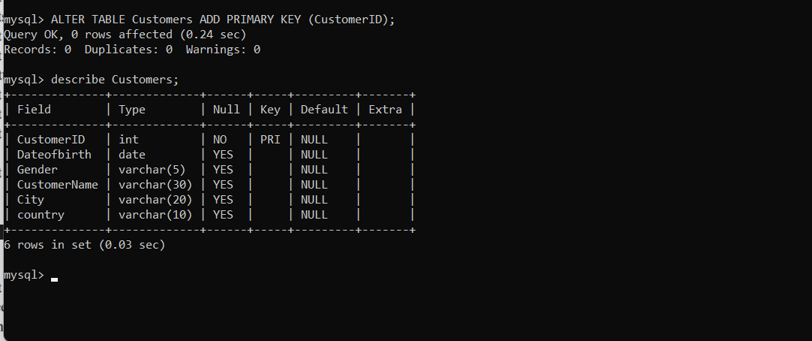

2. Set ProductID in the products table as Foreignkey which references CustomerID in

Customers table.

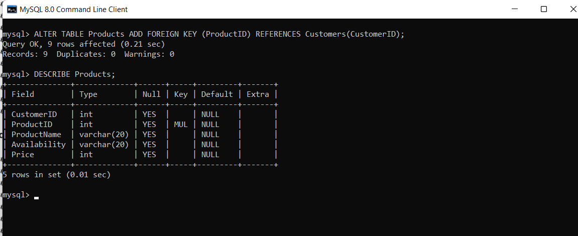

3. Set a default value for Availability as “YES; 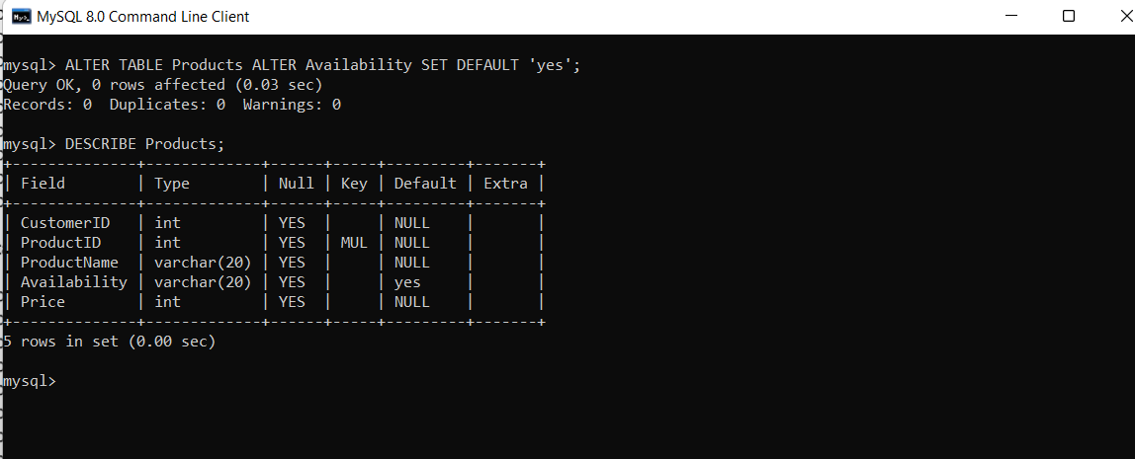

4. Selects all customers with a CustomerName that have "or" in any position

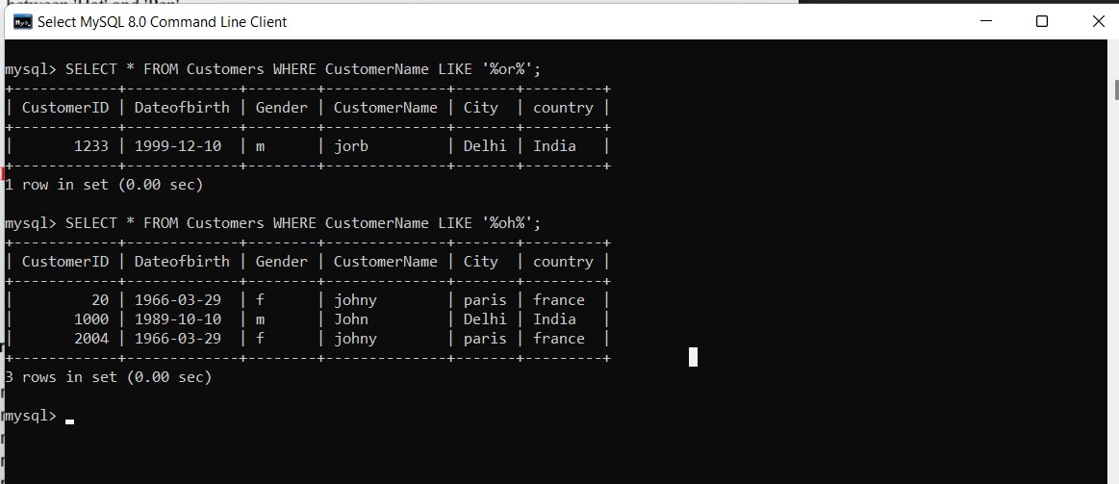

5. Insert CustomerID =2505 in Products table (Assume CustomerID=2505 is not there in Customers table) 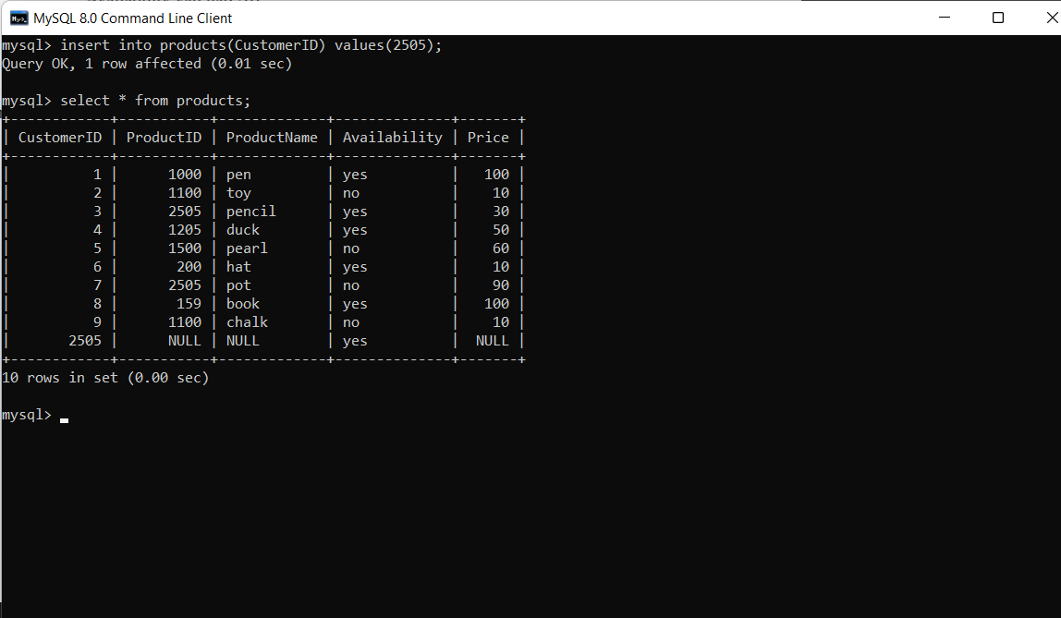

6. Select all fields from "Customers" where country is "Germany" and city is "Berlin".

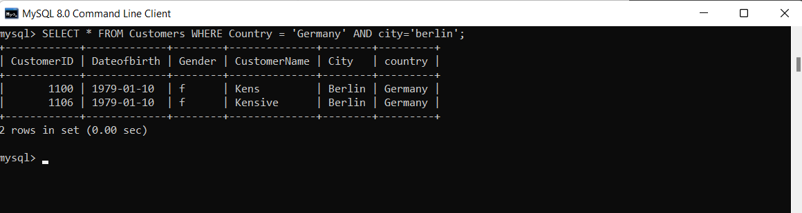

7. Selects all fields from "Customers" where the country is not "Germany".

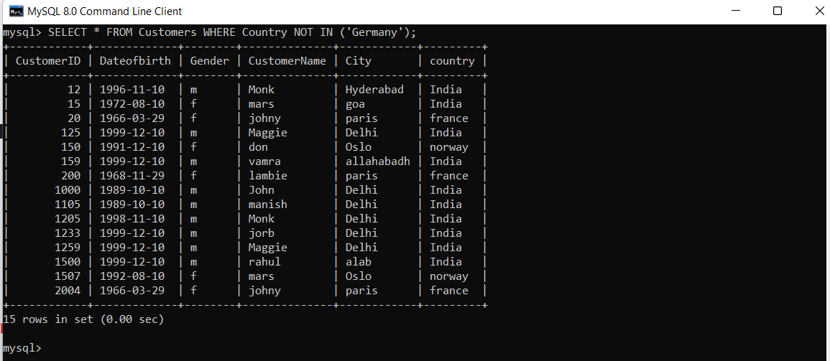

8. Select all records where the value of the City column starts with the letter "a".

(these cities are not given in assignment I inserted manually )

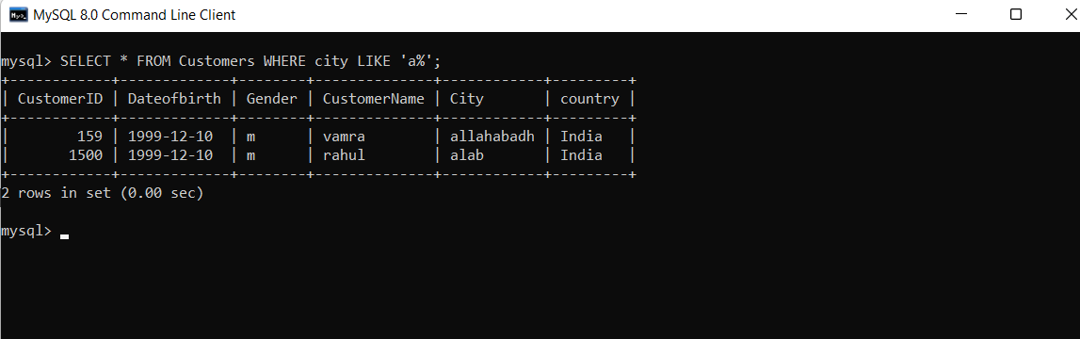

9. Select all records where the value of the City column starts with letter "a" and ends with the letter "b".

(this citiy is not given in assignment I inserted manually )

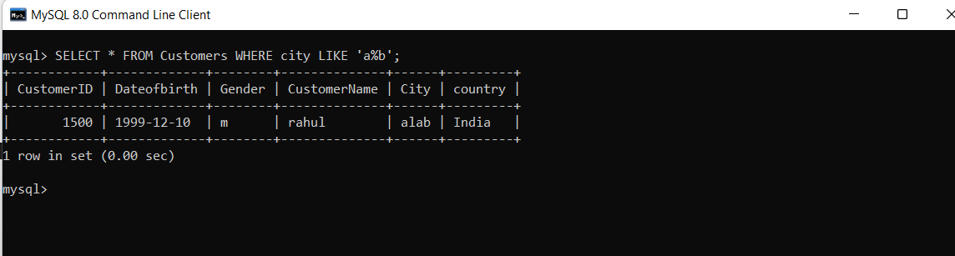

10. Select all records where the value of the City column does NOT start with the letter "a".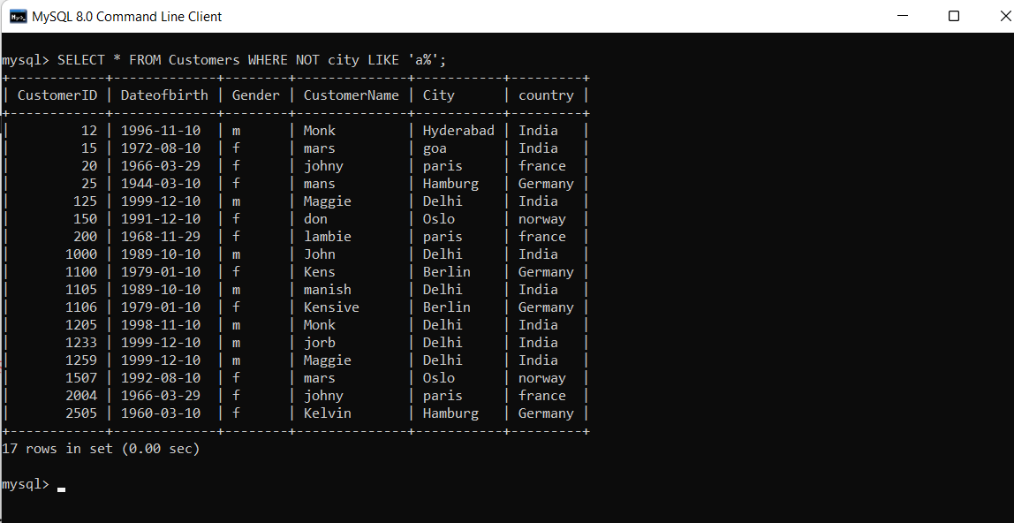

11. Select all records where the first letter of the City is an "a" or a "c" or an "s".

(these cities are not given in assignment I inserted manually )

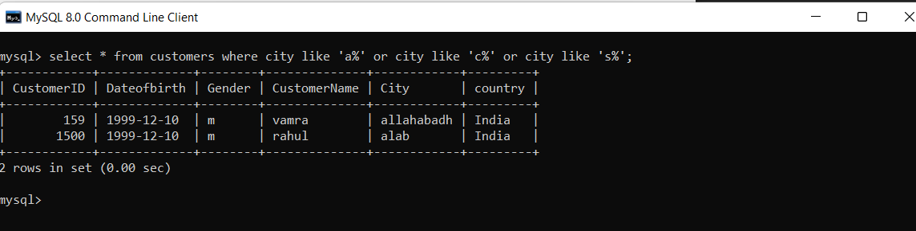

12. Select all records where the first letter of the City starts with anything from an "a" to an "f".

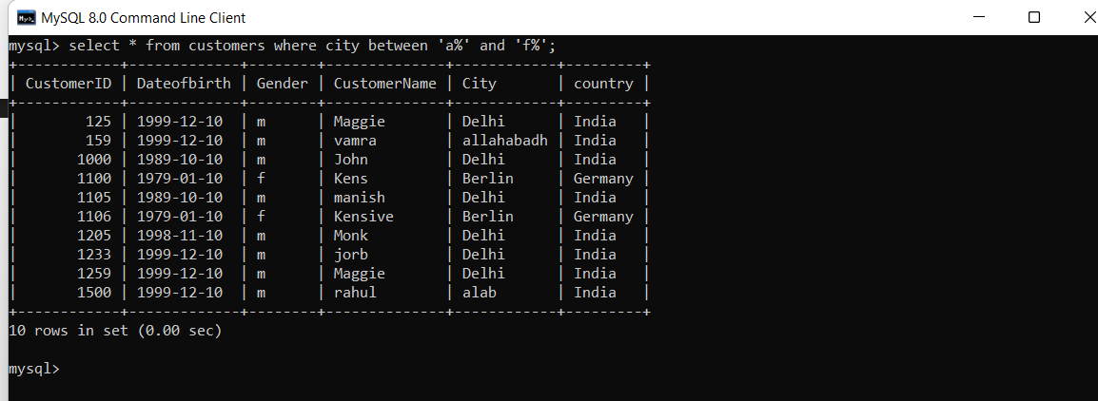

13. Select all the records where the Country is NOT "Norway" and NOT "France".

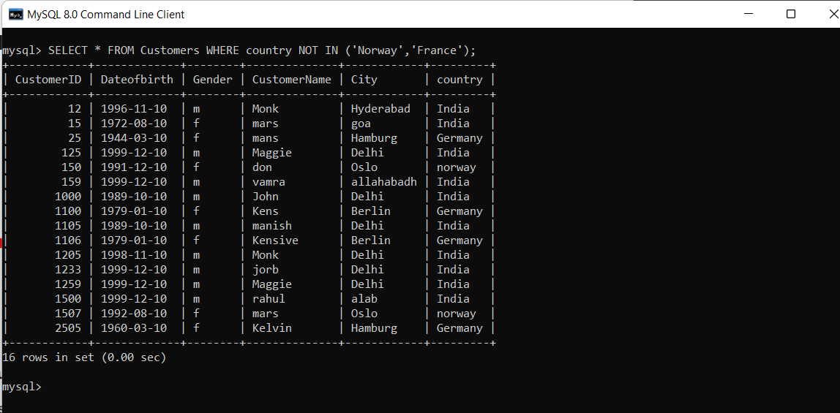

14. Select all the records where the value of the ProductName column is alphabetically

between 'Hat' and 'Pen'.

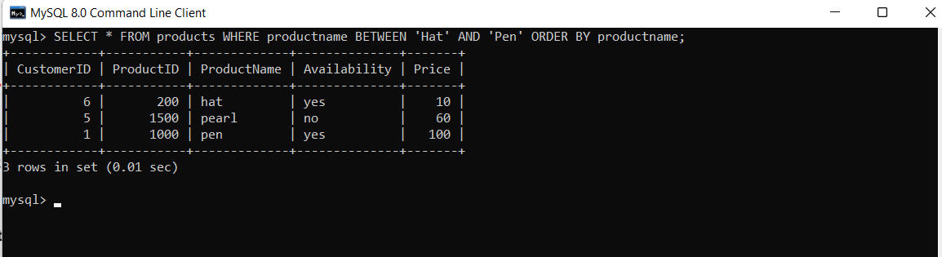

15. List the customer names if it finds any records in the products table that price = 100: 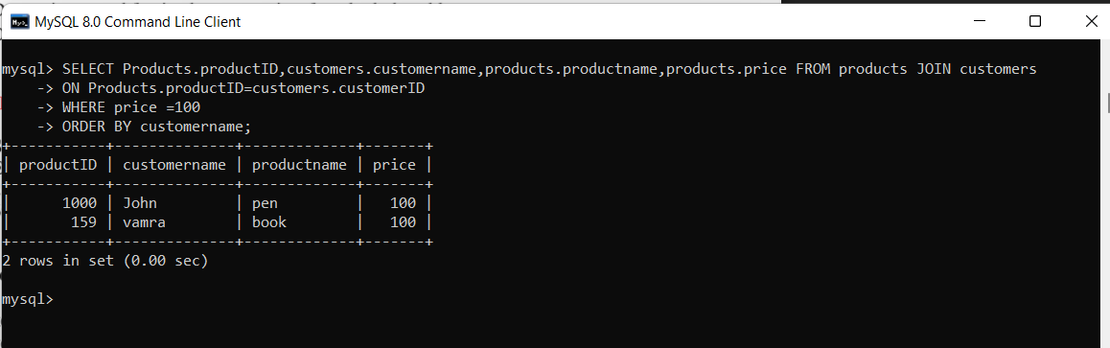

16. List the customer names if it finds all records in the products table that price = 1000: 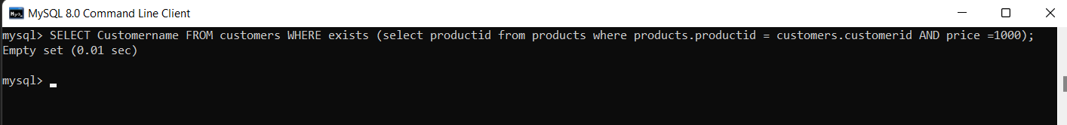

17. Drop primary and foreign key constraints from both the tables.

Before dropping foreign key we should find it’s constraint name

And using constraint name we can drop foreign key.

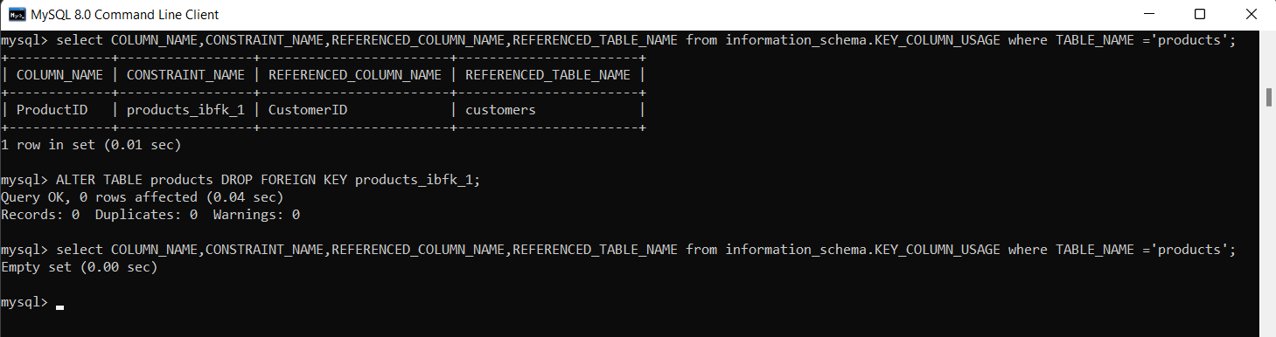

Now if we check the foreign key is dropped (in the below figure)

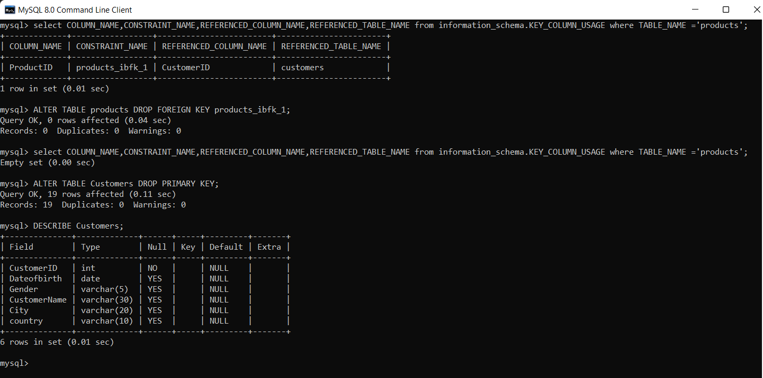

18. Delete the record of all customers who are from country Brazil and city Victoria. 